1. Document Control

## Revision History

|  |  |  |  |  |
| --- | --- | --- | --- | --- |
| **SNO#** | **Version** | **Date** | **Author** | **Change Summary** |
| 1 | 1.01 | 20.11.2020 | Pravin Durai | First Version |

## Key Reviewers

|  |  |  |
| --- | --- | --- |
| Department | Role | Name |
|  |  |  |

## Approvals

|  |  |  |
| --- | --- | --- |
| Role | Date | Name |
|  |  |  |

1. Contents
2. Document Control......................................................................................
   1. Revision History ......................................................................
   2. Key Reviewers.........................................................................
   3. Approval.................................................................................
3. Contents.....................................................................................................
4. Initial Setup
   1. Introduction..............................................................................
   2. Initial Setup..............................................................................
5. Functionalities (General)
   1. Generate Mode.........................................................................
   2. Creating New Partner................................................................
   3. Accessing Existing Partner.........................................................
   4. Create New Operation..............................................................
   5. Loading Existing Operations.......................................................
   6. Generate new configuration files................................................................................................
   7. Editing Existing Operations..............................................................
6. File Comparison
   1. View Difference...............................................................................
7. Git Operations
   1. Check- In...............................................................................
   2. Check-Out...............................................................................
8. Introduction

## Purpose and Objective

This document explains how the developers/functional team should use GCAT to generate the configuration files for various scenario. With GCAT automation tool we should be able to reduce the number of manual errors as well as the time taken to configure them manually.

## Initial Setup

After installing the application go to Edit -> Settings and update the input/output and git path.

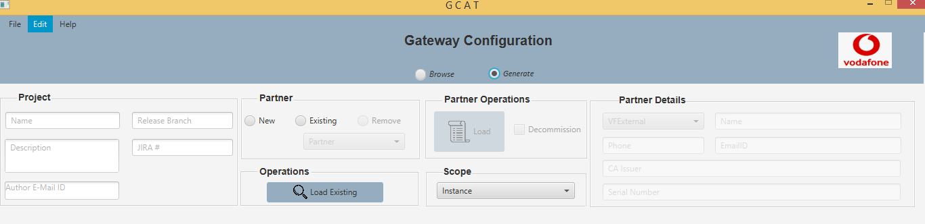

Fig 1

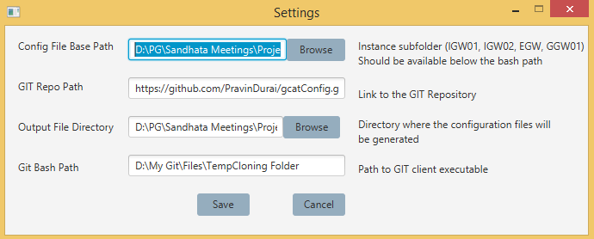

Fig 2

Close and re-open the application for the changes to take place.

1. Functionalities (General)

## Generate Mode

Once you switch to generate mode we should be able to see certain features that were getting enabled. This allows you to create new/update the existing cfg files specified in the path (Fig 2).

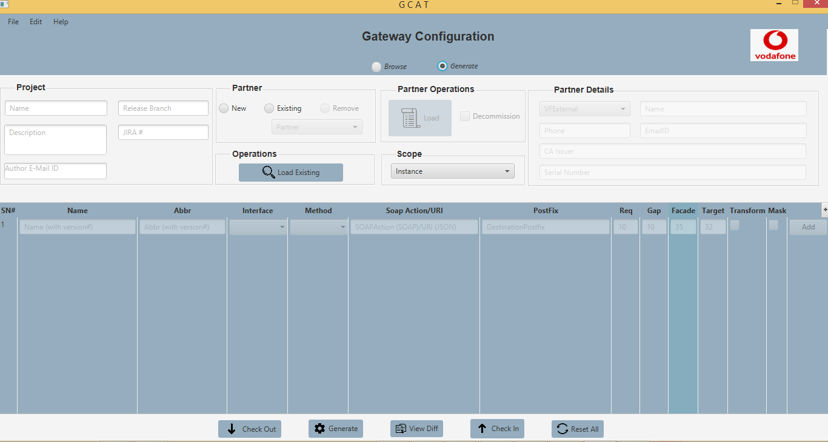

Fig 3

## Creating New Partner

Create a new partner by switching to “New” under Partner.

Once we select New as option we should be able to see Partner Details getting enabled.

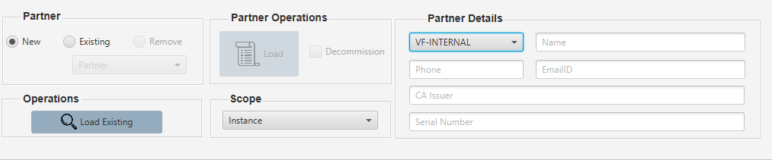

Fig 4

## Existing Partner

For existing partner

1. Select the mode as “Generate”
2. Select Instance under Scope.
3. Select “Existing” under Partner.
4. Select the partner from the list of available partners from partner drop-down under Partner.
5. Click “Load” under Partner Operation

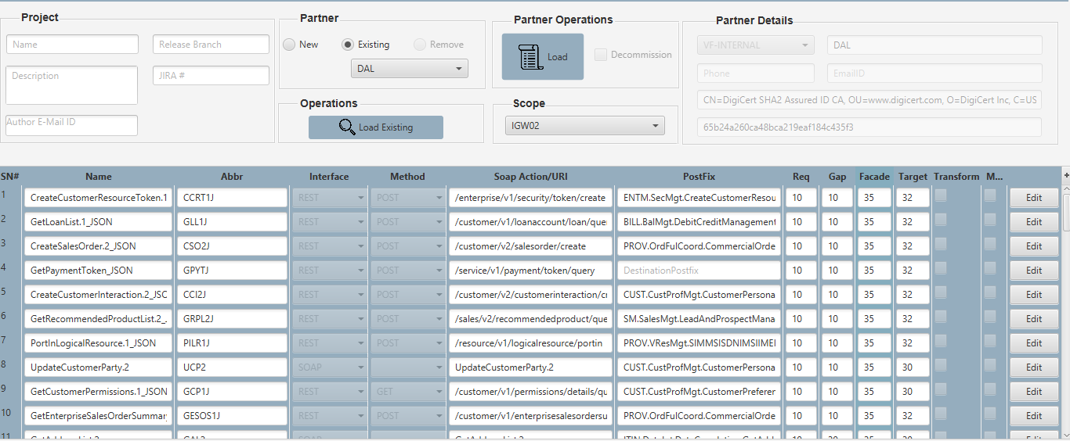

Fig 5

***Note*** :

Make sure partner details are getting populated under “Partner Details” when you click load. When you click on load all the existing operation for the selected partner will be loaded into the grid.

## Create New Operation

For creating a new operation,

1. Select mode as “Generate”
2. Select an Instance under scope for which you wish to add a new operation
3. Enter the details of the operation in the grid and click “Add” (Fig 6)
4. New entries (Fig 7)

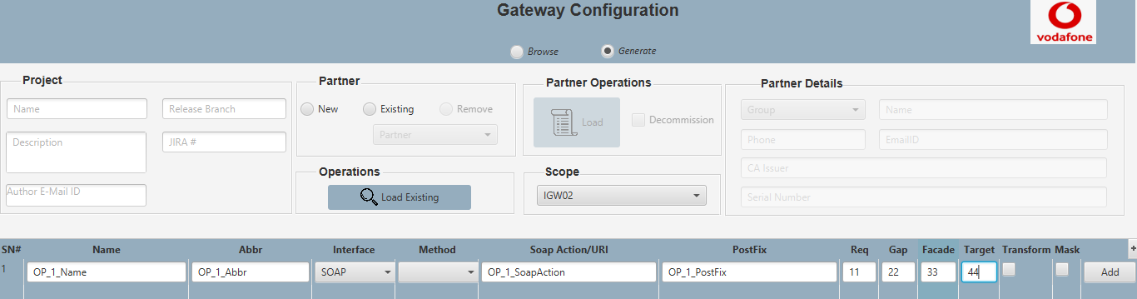

Fig 6

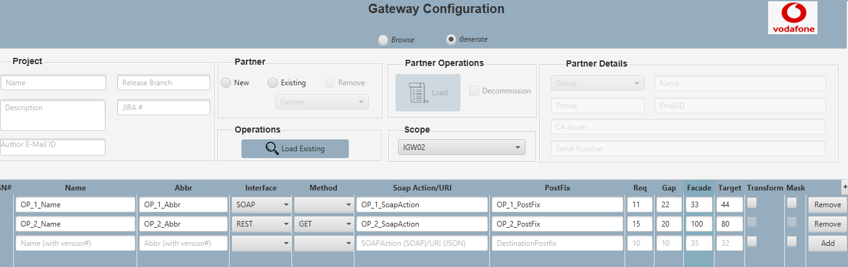

Fig 7

## Load Existing Operation

To load an existing operation,

1. Select mode as “Generate”
2. Select an instance under scope
3. Click “Load Existing” under Operations (Fig 8). Now Operation popup opens displaying the list of available operations for the selected instance (Fig 9)

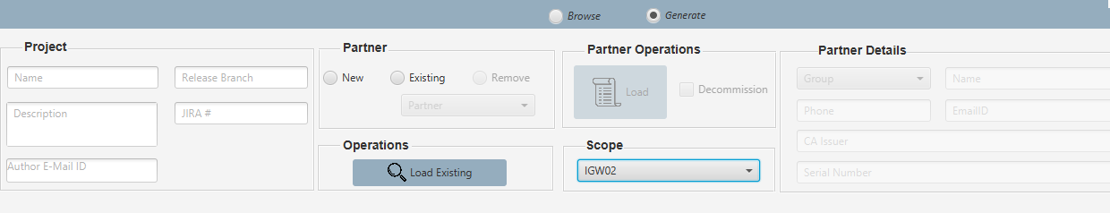

Fig 8

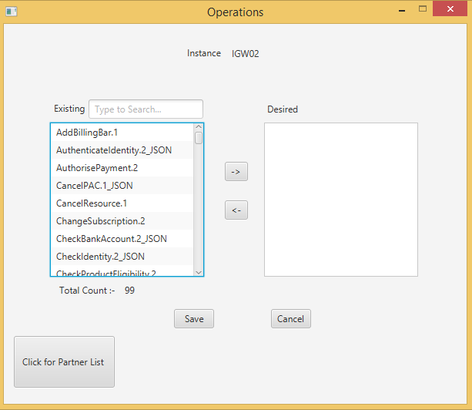

Fig 9

1. Select the operation/operations (use Shift/Ctrl keys) that has to be added for the new/existing partner (Fig 10)

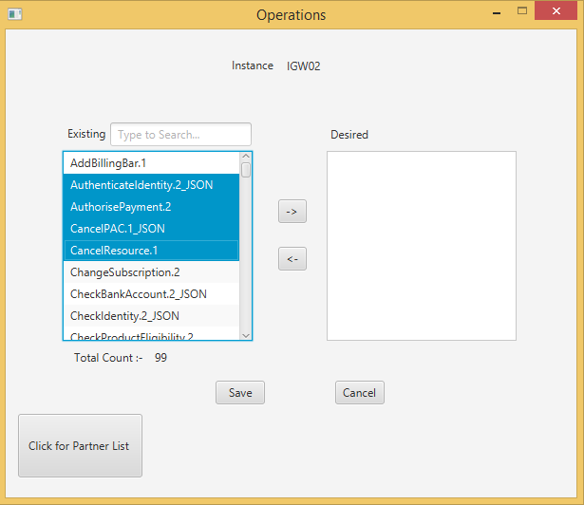

Fig 10

1. Once selected we can use the move buttons to move the operation to the right (Fig 11)
2. Click Save. The selected operation on the right will be exported to the grid along with their data

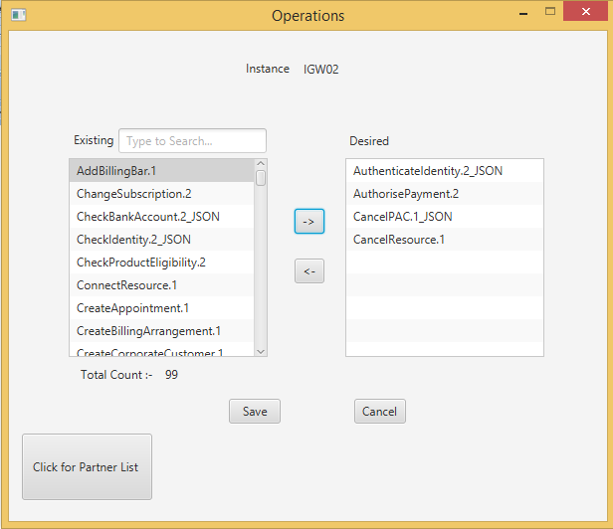

Fig 11

## Generating new cfg files

To generate new configuration/to update existing configuration

1. Select mode as “Generate”
2. Select an instance under Scope
3. Select New/Existing partner under “Partners”

* New partner – Section III
* Existing Partner – Section IV

1. Enter New/Select Existing Operation

* New Operation – Section V
* Existing Operation – Section VI

1. Click Generate
2. The files will be created in the output path specified in (Fig 2).

## Editing Existing Operation

To edit an existing operation

1. Select mod as “Generate”
2. Select an instance under Scope
3. Click Existing Operation (Section IV)

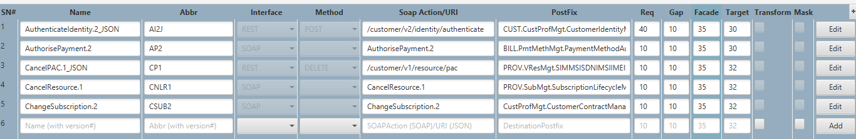

Fig 12

1. Once the existing operations are loaded, select “Edit” button in the grid and you should be able to make the required changes and once the changes are made click save for the changes to reflect.

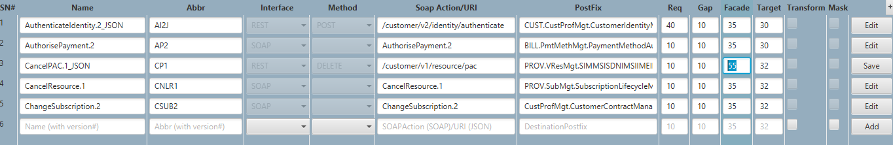

Fig 13

***Note :***

With the existing version of the tool we can edit only Req, Gap, Facade, Target.

We can also enable or disable transform and mask for SOAP request but not for REST.

1. File Comparison

## View Difference

This feature allows us to check the files that are modified. To compare the difference,

1. Select the instance under scope
2. Click ViewDiff button.
3. Git Operations

## Check Out

Before we start using the Application we get the updated configuration folders that are available in the git repository using the checkout option.

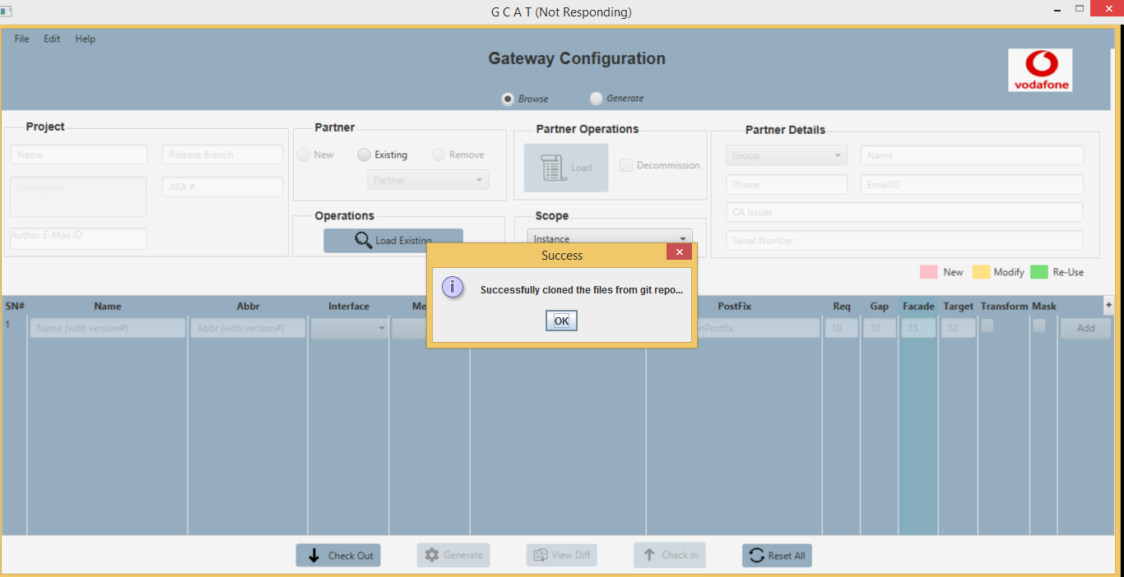

Fig 14

## Check In

Once we have made the required changes we push the updated configuration files in the ouput folder to the Git path that we have specified in Fig2

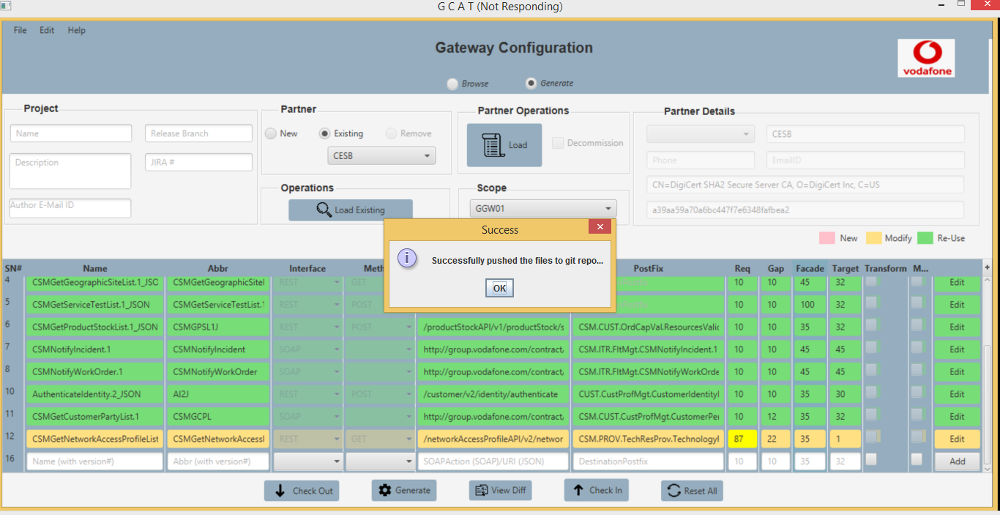

Fig 15

***Note :***

With the existing version of the tool the check-in and check-out has to be done each and every time when we perform a generate function just to make sure we have the right configuration and also to remove duplicates.